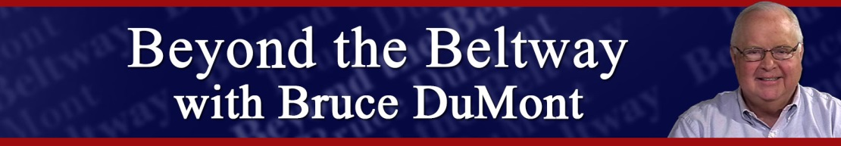

Satellite Audio Distribution Information

- Program distributed on Westwood One satellite carrier via the X-Digital Systems (XDS) platform
- Instructions on scheduling programs in the XDS receiver can be located at this link: http://myxdsreceiver.cmneng.com/aff/Documentation/XDS_Pro_Scheduler_Primer.pdf
- Programs may be scheduled via Calendar method
- Authorization is not necessary
- Locate the programs in the XDS “Program List” tab as follows:

Beyond the Beltway w/ Bruce DuMont

NET CUE ASSIGNMENTS:
LOCAL BREAK P11

Stations with questions about XDS should contact Affiliate Technical Services Department, Monday through Friday, 9:00 am to 6:00 pm, ET at techservices@westwoodone.com or (914) 908 - 3210.
Stations with satellite difficulties during the LIVE feed should call the Purchase, NY - Technical Operating Center at (914) 908 – 3220.
Stations with programming questions about Beyond the Beltway programs should contact Collin Bobbitt via telephone 773-459-4130 or email at Collin.ashmeadbobbitt@gmail.com

